Week 1 Assignment
SRS Document Development and GitHub

John Home
The University of Arizona Global Campus
CST 499: Capstone for Computer Software Technology
Dr. Charmelia Butler
6/12/2023

Software Requirements Specification
for
Course Enrollment Webpage
Version 1.0 approved
Prepared by John Home
CST 499 Capstone for Computer Software Technology
6/12/2023
Table of Contents
Table of Contents ii
Revision History ii
1. Introduction 1
1.1 Purpose 1
1.2 Document Conventions 1
1.3 Intended Audience and Reading Suggestions 1
1.4 Product Scope 1
1.5 References 1
2. Overall Description 2
2.1 Product Perspective 2
2.2 Product Functions 2
2.3 User Classes and Characteristics 2
2.4 Operating Environment 2
2.5 Design and Implementation Constraints 2
2.6 User Documentation 2
2.7 Assumptions and Dependencies 3
3. External Interface Requirements 3
3.1 User Interfaces 3
3.2 Hardware Interfaces 3
3.3 Software Interfaces 3
3.4 Communications Interfaces 3
4. System Features 4
4.1 System Feature 1 4
4.2 System Feature 2 (and so on) 4
5. Other Nonfunctional Requirements 4
5.1 Performance Requirements 4
5.2 Safety Requirements 5
5.3 Security Requirements 5
5.4 Software Quality Attributes 5
5.5 Business Rules 5
6. Other Requirements 5
Appendix A: Glossary 5
Appendix B: Analysis Models 5
Appendix C: To Be Determined List 6

Revision History
Name | Date | Reason For Changes | Version

Introduction

Purpose
The purpose of this software is to provide a system for students to utilize that will allow them to review the classes available in a specific semester, sign up for classes, or add themselves to a wait list if the classes are not available. The system will track the availability of each class and provide the users on the waitlist the opportunity to enroll if a slot becomes available.

Document Conventions
<Describe any standards or typographical conventions that were followed when writing this SRS, such as fonts or highlighting that have special significance. For example, state whether priorities for higher-level requirements are assumed to be inherited by detailed requirements, or whether every requirement statement is to have its own priority.>

Intended Audience and Reading Suggestions
This document is intended to be utilized by other developers to help understand the purpose of the software if changes are needed. Project managers to be able to set milestones to determine if the project is on track and filling the need it is designed for. Marketing staff to provide information to potential stakeholders who may want to utilize the software. Testers to understand what the software is going to do so it can be accurately tested. Document writers to create proper guides on how the software is utilized for end users and stakeholders. Users so they know what the software should do when they are working with it.
Throughout the rest of this document details about the scope, use cases, functionality, and technical details will be provided. This will include both software functions and design ideas as well and environmental variables.

Product Scope
The enrolment website software will give a single location for students to visit and identify courses that are available for the semester. Students will be able to sign up for courses they want to take and if the course is unavailable put themselves on a waiting list. Students will be able to review courses available in future semesters to help them plan out their course loads and ensure they get the classes they need. The software will track the availability of classes and track how many slots are available. Once the available slots are full the software will track the order of the wait list and inform any students on the wait list if a slot becomes available.
This software will allow the university or educational organization the ability to help students enroll for the classes they need. This will free up some time for staff to help students with additional needs because the students who have a strong understanding of their needs will be able to self service. The educational organization will also benefit from a place for students to track their class availability.

References
<List any other documents or Web addresses to which this SRS refers. These may include user interface style guides, contracts, standards, system requirements specifications, use case documents, or a vision and scope document. Provide enough information so that the reader could access a copy of each reference, including title, author, version number, date, and source or location.>

Overall Description

Product Perspective
This program will be a new self-contained program. The software will utilize a back end database to store and organize information and a web server to broadcast the front end website and application. Because of the importance for having registration done for a specific time the site will be required to be functional twenty four hours a day, seven days a week during registration periods.

Product Functions
- User will sign into web portal utilizing a unique username and password
- User will select the semester they are interested in getting information on
- User will have a drop down of available classes for that semester
- User will have the option of registering for a class
- System will determine if slots are available
- System will remove an available slot and register user for that slot
- If slot is not available user will be placed on waiting list
- If slot becomes available the user will be notified via email
- Administrators will be able to sign in and see total for classes registered, available slots, and attendance to the website.
- Administrators will be able to pull a list of students registered for classes.

User Classes and Characteristics
- System administrator: responsible for maintaining back end database and functionality.
- End User: Students looking to sign up for classes.
- Administrator: Educational facilitator looking at overall registration and availability.

Operating Environment
Website will be hosted from windows OS server. Back end database will be MySQL. Web environment will be PHP. User interface will be a website available to users on windows, MacOS, and Android devices.

Design and Implementation Constraints
- Software will need to be viewable on all variations of screen size, including mobile.

User Documentation
Short presentation on software features and usage will be provided with software do direct users on full use of website.

Assumptions and Dependencies
<List any assumed factors (as opposed to known facts) that could affect the requirements stated in the SRS. These could include third-party or commercial components that you plan to use, issues around the development or operating environment, or constraints. The project could be affected if these assumptions are incorrect, are not shared, or change. Also identify any dependencies the project has on external factors, such as software components that you intend to reuse from another project, unless they are already documented elsewhere (for example, in the vision and scope document or the project plan).>

External Interface Requirements

User Interfaces
- Screen size must be adjustable for multiple device types. Screen should adjust automatically to the device being utilized.
- Website layout should adjust to the type of device the website is being viewed on.
- Error should be displayed if user enters incorrect username or password.
- Error should be displayed if user is not registered for website.
- Notification should be provided if class is no longer available
- Prompt should be provided to join waiting list.
- Buttons should be easily identifiable
- Drop downs should be in convenient location so full list can be viewed
- Semester should be easily identifiable when user is trying to register

Hardware Interfaces
<Describe the logical and physical characteristics of each interface between the software product and the hardware components of the system. This may include the supported device types, the nature of the data and control interactions between the software and the hardware, and communication protocols to be used.>
- Hardware should support and enforce HTTPS protocols
- Username and passwords should be encrypted during storage
- Software should adjust layout and sizes to meet screen size of device being utilized.

Software Interfaces
<Describe the connections between this product and other specific software components (name and version), including databases, operating systems, tools, libraries, and integrated commercial components. Identify the data items or messages coming into the system and going out and describe the purpose of each. Describe the services needed and the nature of communications. Refer to documents that describe detailed application programming interface protocols. Identify data that will be shared across software components. If the data sharing mechanism must be implemented in a specific way (for example, use of a global data area in a multitasking operating system), specify this as an implementation constraint.>

Communications Interfaces
<Describe the requirements associated with any communications functions required by this product, including e-mail, web browser, network server communications protocols, electronic forms, and so on. Define any pertinent message formatting. Identify any communication standards that will be used, such as FTP or HTTP. Specify any communication security or encryption issues, data transfer rates, and synchronization mechanisms.>

System Features
<This template illustrates organizing the functional requirements for the product by system features, the major services provided by the product. You may prefer to organize this section by use case, mode of operation, user class, object class, functional hierarchy, or combinations of these, whatever makes the most logical sense for your product.>

System Feature 1
<Don’t really say “System Feature 1.” State the feature name in just a few words.>
4.1.1 Description and Priority
<Provide a short description of the feature and indicate whether it is of High, Medium, or Low priority. You could also include specific priority component ratings, such as benefit, penalty, cost, and risk (each rated on a relative scale from a low of 1 to a high of 9).>
4.1.2 Stimulus/Response Sequences
<List the sequences of user actions and system responses that stimulate the behavior defined for this feature. These will correspond to the dialog elements associated with use cases.>
4.1.3 Functional Requirements
<Itemize the detailed functional requirements associated with this feature. These are the software capabilities that must be present in order for the user to carry out the services provided by the feature, or to execute the use case. Include how the product should respond to anticipated error conditions or invalid inputs. Requirements should be concise, complete, unambiguous, verifiable, and necessary. Use “TBD” as a placeholder to indicate when necessary information is not yet available.>

<Each requirement should be uniquely identified with a sequence number or a meaningful tag of some kind.>

REQ-1:
REQ-2:

System Feature 2 (and so on)

Other Nonfunctional Requirements

Performance Requirements
<If there are performance requirements for the product under various circumstances, state them here and explain their rationale, to help the developers understand the intent and make suitable design choices. Specify the timing relationships for real time systems. Make such requirements as specific as possible. You may need to state performance requirements for individual functional requirements or features.>

Safety Requirements
<Specify those requirements that are concerned with possible loss, damage, or harm that could result from the use of the product. Define any safeguards or actions that must be taken, as well as actions that must be prevented. Refer to any external policies or regulations that state safety issues that affect the product’s design or use. Define any safety certifications that must be satisfied.>

Security Requirements
<Specify any requirements regarding security or privacy issues surrounding use of the product or protection of the data used or created by the product. Define any user identity authentication requirements. Refer to any external policies or regulations containing security issues that affect the product. Define any security or privacy certifications that must be satisfied.>

Software Quality Attributes
<Specify any additional quality characteristics for the product that will be important to either the customers or the developers. Some to consider are: adaptability, availability, correctness, flexibility, interoperability, maintainability, portability, reliability, reusability, robustness, testability, and usability. Write these to be specific, quantitative, and verifiable when possible. At the least, clarify the relative preferences for various attributes, such as ease of use over ease of learning.>

Business Rules
<List any operating principles about the product, such as which individuals or roles can perform which functions under specific circumstances. These are not functional requirements in themselves, but they may imply certain functional requirements to enforce the rules.>

Other Requirements
<Define any other requirements not covered elsewhere in the SRS. This might include database requirements, internationalization requirements, legal requirements, reuse objectives for the project, and so on. Add any new sections that are pertinent to the project.>
Appendix A: Glossary
<Define all the terms necessary to properly interpret the SRS, including acronyms and abbreviations. You may wish to build a separate glossary that spans multiple projects or the entire organization, and just include terms specific to a single project in each SRS.>
Appendix B: Analysis Models
<Optionally, include any pertinent analysis models, such as data flow diagrams, class diagrams, state-transition diagrams, or entity-relationship diagrams.>
Appendix C: To Be Determined List
<Collect a numbered list of the TBD (to be determined) references that remain in the SRS so they can be tracked to closure.>

GitHub Active Web Pictures.

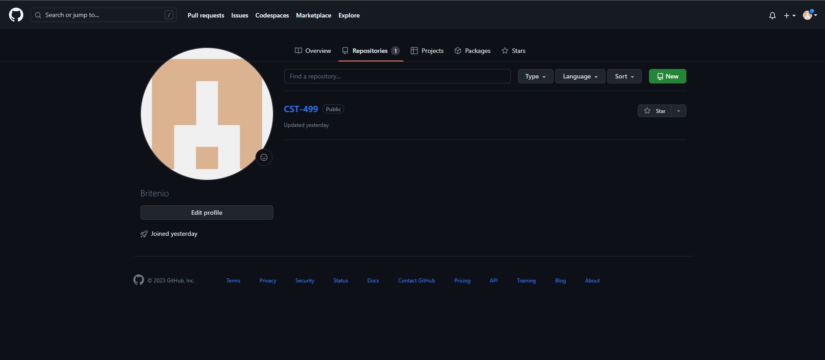
GitHub Desktop App
